Guest72019 Eva Bartosova | ½–½ | Chessflower1465
5m + 0s1.e4 2.5 e5 3.6 2.Nf3 2.4 Nc6 2.9 3.Bb5 2.2d6 1.8 4.d3 1.9 Bd7 1.7 5.Bxc6 2 bxc6 2.36.0-0 2.9 h6 1.7 7.Nc3 4.4 Nf6 2.1 8.b4 7Be7 1.9 9.a3 2.3 a6 3.4 10.Bb2 5.6 0-0 1.711.Ne2 5.1 Nh7 18 12.Ng3 2.4 Ng5 2.613.Bc1 8 Nxf3+ 2.4 14.Qxf3 3.2 Bg5 2.315.Bxg5 4.8 Qxg5 2.2 16.Qh5 4.8 Qf4 1317.Qf3 3.3 Qg5 6.6 18.Nf5 5.1 Bxf5 3.519.Qxf5 2.2 Qd2 5.4 20.Rfc1 6.9 g6 521.Qd7 3.2 a5 15 22.Qxc7 8.8 axb4 423.Qxc6 6.7 Rxa3 4.8 24.Qxd6 19 Rfa8 1425.Qxe5 16 Rxa1 15 26.Rxa1 2.7 Rxa1+ 2.927.Qxa1 2.2 Qxc2 2.2 28.h3 9.1 b3 1.729.Qa8+ 5.6 Kg7 4.7 30.Qd5 6.5 Qc3 1431.d4 11 b2 6.4 32.Qe5+ 4.5 Kf8 4.633.Qh8+ 5.1 Ke7 2.7 34.Qe5+ 2.8 Kd7 7.735.Qd5+ 7.9 Kc7 6.4 36.Qe5+ 7.7 Kb6 2.637.Qd6+ 7.5 Qc6 3 38.Qb4+ 2.9 Qb5 1.839.Qd6+ 2.2 Ka5 8.9 40.Qa3+ 3.8 Kb6 3.341.Qd6+ 3.5 Qc6 3.4 42.Qb4+ 3.3 Qb5 4.643.Qd6+ 2.3½–½

Guest176353 | 0–1 | Guest169469 Eva Bartosova
5m + 0s1.e4 4.9 e5 2.6 2.Nf3 7.6 d6 1.7 3.Bc418 Bg4 3.7 4.Rg1 12 Nc6 20 5.d3 20Bxf3 4.8 6.Qxf3 7.4 Nd4 4.3 7.Qg4 20Nxc2+ 12 8.Kd2 210–1

Guest176353 | 0–1 | Guest169469 Eva Bartosova
5m + 0s1.e3 5.8 e5 2.1 2.f4 11 d6 7.7 3.d4 7.5exd4 3 4.Qxd4 22 Nf6 3.1 5.Bb5+ 12Bd7 2.8 6.Na3 15 Bxb5 3.9 7.Nxb5 16Na6 2.5 8.Nf3 20 Qd7 4.7 9.Qc4 12Nc5 16 10.Nfd4 39 Be7 3.4 11.g3 150-0 4.3 12.Rf1 17 a6 9 13.Rg1 0.30–1

 | Guest42315 | 0–1 | Guest38413 Eva Bartosova
 | Zaujimava partia
5m + 0s1.e4 0.3 e5 3.6 2.Nf3 1.1 d6 2.73.Bc4 0.8 Nc6 3.4 4.d4 1.4 Nxd4 25.Nxd4 0.3 exd4 1.6 6.Qxd4 1.1 Be63.5 7.Be2 3.5 Qd7 4.3 8.f4 2.3 b64.3 9.f5 1.5 Bxf5 6.5 10.exf5 1.7Qxf5 1.8 11.Qd3 6.8 Qe5 17 12.0-07.8 0-0-0 2.8 13.Nc3 2.3 Kb8 2.814.Bf3 6.5 Be7 3.7 15.Qa6 1.2 d59.9 16.Nxd5 2.4 Rxd5 3.1 17.Bf4 8.1Qxf4 8.5 18.Bxd5 3.4 Qd4+ 4.819.Rf2 12 Qxd5 1.8 20.Raf1 6.7 Bc56.9 21.c4 4 Bxf2+ 2.9 22.Rxf2 2.3Qd4 3 23.Kf1 2.2 Qd1# 4.6 (Lag: Av=0.20s, max=0.5s)

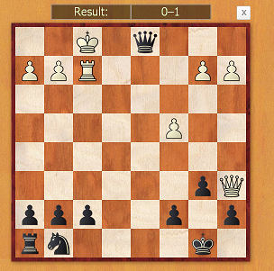

Guest53015 Eva Bartosova | 1–0 | Guest53024
5m + 0s1.e4 2 d6 2.2 2.d4 1.8 Nf6 2.3 3.Nc36.2 c6 2.3 4.Bg5 2.5 e6 4.6 5.Nf3 2.9Be7 2.1 6.Be2 2.7 Nbd7 5 7.0-0 30-0 1.8 8.Nh4 5.6 Ne8 9.8 9.f4 2.3f6 1.9 10.Bh6 7.3 gxh6 12 11.Bh52.5 Ng7 5.2 12.Qg4 4.3 f5 7.113.exf5 2.6 exf5 7.3 14.Nxf5 2.3 Bf65.2 15.Rf3 5.3 Bg5 14 16.fxg5 18Qxg5 5.7 17.Nxh6+ 9.3 Qxh6 518.Raf1 17 Nf6 7.7 19.Rxf6 4.9 Bxg41.8 20.Bf7+ 7.9 Rxf7 14 21.Rxh6 5.7Raf8 9.1 22.Rxf7 5.3 Rxf7 2.223.Rxd6 2.4 Nf5 6.1 24.Rd8+ 4.5Kg7 2.7 25.Ra8 2.5 a6 2.3 26.d5 6c5 14 27.Ne4 8.8 c4 7.7 28.d6 4.9Rd7 3.8 29.Rc8 12 b5 13 30.Rc72.1 Nxd6 3.1 31.Rxd7+ 4.8 Bxd7 232.Nxd6 1.6 Kf6 4.7 33.Nb7 7 Ke59.5 34.Nc5 7.7 Bc6 2.7 35.Nxa6 2.2Kd4 2.6 36.Nb4 14 c3 4.3 37.bxc3+9.5 Kxc3 6.8 38.Nxc6 1.6 b4 2.439.Na5 4.2 Kb2 3.6 40.Kf2 17 Kxc22 41.Ke2 1.7 h6 4.3 42.g4 2.1Guest53024 resigns1–0

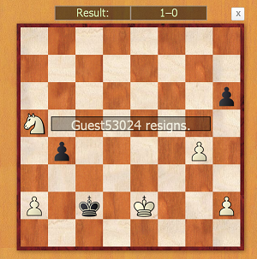

kartal29 | 0–1 | Guest59719 Eva Bartosova
Zaujimava partia
5m + 0s1.e4 1.7 e5 1.8 2.Nf3 0.9 d6 2.1 3.Bc4 1.2Nc6 2 4.Nc3 3.5 Bg4 2.9 5.Be2 3.2 Bxf3 6.96.Bxf3 1.6 Nd4 1.1 7.0-0 2.8 Ne6 6.6 8.d3 7.6Nf4 1.3 9.Bxf4 2.3 exf4 1.5 10.Nd5 9.7 Nf65.1 11.Nxf4 2.6 Be7 8.3 12.Nh5 1.8 Nxh5 5.513.Bxh5 2.1 g6 2.5 14.Bf3 5.6 Bg5 2.9 15.e51.8 dxe5 2.6 16.Bxb7 2.4 Rb8 2.3 17.Bc6+1.6 Kf8 3.9 18.b3 1.3 Kg7 2.6 19.Qe2 9.8Qd6 5.4 20.Ba4 9.8 h5 1.4 21.Rad1 15 Rh62.4 22.c3 4.8 Rbh8 3.9 23.d4 2.1 exd4 1224.Rxd4 5.9 Qf8 14 25.Qe5+ 4 Bf6 4.226.Qxf6+ 28 Kxf6 2.8 27.Re1 7.6 h4 2.328.h3 6.2 g5 14 29.Rde4 13 Rg6 15 30.Re8 7Qg7 3.2 31.R8e5 10 g4 4.3 32.R1e3 9.5 gxh36.4 33.g3 18 hxg3 7.5 34.R5e4 10 h2+ 8.4kartal29 gibt auf0–1

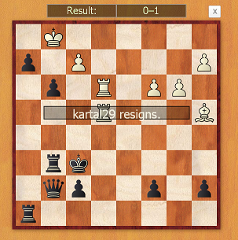

Guest49454 | 0–1 | Guest59719 Eva Bartosova
5m + 0s1.e4 1.9 e5 1.5 2.Nf3 1.5 d6 2.53.Nc3 3.3 Nc6 3.4 4.h3 3.6 Be6 135.Bc4 0.9 Qd7 2.40–1

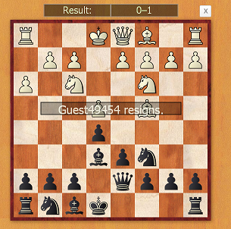

Guest142911 Eva Bartosova | 1–0 | Guest142854
Zaujimava hra
5m + 0s1.e4 4.2 g6 2.6 2.d4 1.7 Bg7 1.7 3.Nf3 2 b6 1.54.e5 1.8 Bb7 3.6 5.Be2 3 d6 6.1 6.exd6 5.9cxd6 3.6 7.0-0 3.5 Nf6 5.5 8.c4 5.2 0-0 4.1 9.d54 Qc8 18 10.Nc3 3.1 e6 7.3 11.Bd3 6.9 exd53.6 12.Nxd5 5.6 Bxd5 4.1 13.cxd5 5.9 Nxd5 4.214.Be4 4.2 Nd7 49 15.Bxd5 3.6 Rb8 6.7 16.Ng56.1 Nf6 6.5 17.Rb1 14 Qf5 11 18.Bxf7+ 16 Rxf711 19.Nxf7 2.1 Kxf7 3.3 20.Qxd6 4.2 Qxb1 7.321.Qxb8 5.2 Qxa2 9.6 22.Qb7+ 8.3 Kg8 5.623.Qc8+ 6 Bf8 5.8 24.Rd1 9.8 Ne4 25 25.h3 7Qf7 16 26.Rd7 11 Qxf2+ 5.7 27.Kh1 14 Ng3+4.1 28.Kh2 2.6 Nf1+ 12 29.Kh1 3.1 Ng3+ 2330.Kh2 4.1 Nf1+ 44 31.Kh1 2.8 '1–0

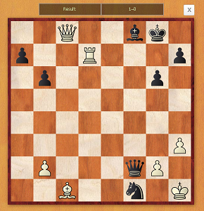

 | Guest294369 | 0–1 | Guest352519 Eva Bartosova
5m + 0s1.d4 2.4 d5 2.5 2.c4 2.4 e6 1.5 3.Nc3 2.7 Nf6 1.94.Bg5 3.1 Be7 2 5.Nf3 5.2 c6 2.5 6.e4 1.8 dxe43.7 7.Bxf6 5.3 Bxf6 1.9 8.Nxe4 3.2 Bd7 2.79.Nxf6+ 2.4 Qxf6 2.8 10.Be2 3.8 Na6 6.6 11.b322 0-0 3.7 12.0-0 2.3 Nb4 8.7 13.a3 22 Na6 2.314.Qd2 4.3 Rfe8 10 15.Rad1 4.4 b6 2.8 16.Bd39.1 c5 6.1 17.dxc5 29 Nxc5 2.5 18.Qc2 5.3 Nxd35 19.Rxd3 5.4 Rad8 6 20.Rfd1 12 Qe7 5 21.a420 Bc6 3.4 22.Ne5 5.1 Be4 4 23.Qc3 23 Bxd3 8.424.Nxd3 2 Rd6 13 25.f4 3.2 Red8 1.9 26.Kf2 8.3Qh4+ 5.6 27.Kf3 5.6 Qxh2 7.50–1

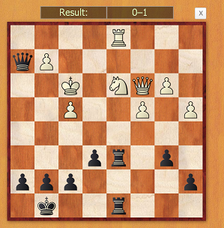

 | Guest314941 | 0–1 | Guest352519 Eva Bartosova
5m + 0s1.d4 7.4 d5 2.3 2.c4 5.1 e6 2.5 3.Nc32.9 Nf6 1.8 4.c5 3.9 c6 1.5 5.Nf3 4Be7 4.3 6.Bg5 1 0-0 2.9 7.Ne5 1.6Nbd7 4.5 8.Nxd7 12 Bxd7 3.4 9.g3 6b6 3.1 10.Bg2 0.8 (Lag: Av=0.26s, max=0.4s)0–1

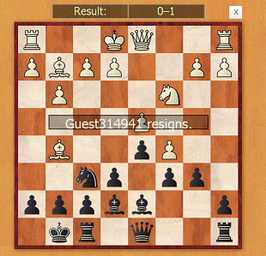

 | Guest358596 | 0–1 | Guest352519 Eva Bartosova
5m + 0s1.e4 0.8 e5 1.7 2.Nf3 1.9 d6 2 3.Bc4 4.1 Nc6 1.8 4.a3 11Bg4 3.6 5.c3 2 Bxf3 2.1 6.Qxf3 6.8 Nf6 3 7.d3 3.6 Be7 2.98.Nd2 20 0-0 1.7 9.Nf1 4.4 Na5 2.4 10.Ba2 3.5 c5 4.7 11.b423 cxb4 2.6 12.axb4 8.6 Nc6 1.6 13.Ne3 24 Qb6 10 14.Nf57.3 Rfe8 5.2 15.Qg3 15 g6 4.7 16.Nh6+ 15 Kh8 9.6 17.Nxf7+12 Kg7 8.1 18.Bh6+ 22 Kg8 7.6 19.Nxd6+ 12 Kh8 4.820.Nxe8 18 Rxe8 3.7 21.0-0 7.7 Nh5 18 22.Qg4 18 Bf6 2.723.Be3 10 Qc7 3.7 24.Bd5 17 Ne7 3.6 25.Bc4 11 Rf8 1426.Rxa7 13 Ng8 15 27.Rc1 17 Qb8 5 Tiempo0–1

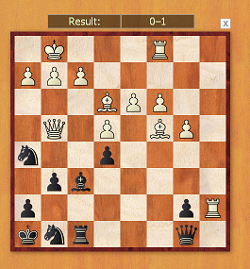

Guest345847 | 0–1 | Guest352519 Eva Bartosova
5m + 0s1.e4 1.4 e5 1.9 2.Bc4 6.5 d6 1.8 3.Nf3 9.7Nc6 2.5 4.h3 4.1 Nf6 5.6 5.c3 13 Be7 4.46.d4 15 exd4 4.4 7.Ng5 12 0-0 5.4 8.0-0 16dxc3 5.2 9.Nxc3 3.6 Ne5 4.6 10.Bb3 12 h64.2 11.Nf3 3.5 Nxf3+ 3.9 12.Qxf3 3.5 Bd79.6 13.Re1 8.7 Qc8 2.5 14.Nd5 9.2 Nxd59.1 15.Bxd5 4.1 Be6 2.8 16.e5 22 dxe5 5.317.Rxe5 5.6 Bxd5 4.1 18.Qxd5 3.1 Bf6 4.619.Re3 32 Rd8 5.4 20.Qh5 16 Qd7 1921.Re1 50 Qd5 4.6 22.Bxh6 17 Qxh5 5.30–1

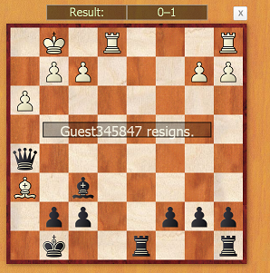

 | Guest419780 | 0–1 | Guest418463 Eva Bartosova
5m + 0s1.e4 0.9 e5 3.6 2.Nc3 1.4 d6 3.2 3.Bc4 1.7 Bd7 7 4.Nf3 1.9Nc6 3 5.d3 2.4 Qe7 5.4 6.Nd5 2.9 Qd8 3.2 7.Bg5 6.2 f6 5.58.Bd2 6.8 Nge7 3.5 9.Nc3 6 Nd4 2.7 10.Nxd4 2 exd4 2.611.Ne2 8.9 Nc6 2.9 12.f4 6.7 Qe7 6.6 13.b4 22 Bg4 1214.h3 3.2 Bxe2 3.7 15.Qxe2 2.3 a6 3.2 16.b5 2.8 axb5 2.817.Bxb5 1.4 0-0-0 5.4 18.Bxc6 9.7 bxc6 1.6 19.0-0 1.5 Kd73.5 20.a4 3.3 g5 6.5 21.fxg5 4.9 fxg5 2.1 22.Qg4+ 2.4 Qe613 23.Rf7+ 5.1 Be7 11 24.Qxe6+ 17 Kxe6 2.3 25.Rf5 5.5Rhg8 4.3 26.a5 4.2 Ra8 3.6 27.a6 2.8 c5 6.3 28.c3 4.7 c61.4 29.cxd4 1.9 cxd4 6.1 30.Ra4 3.8 c5 2 31.g4 36 Bf6 4.632.Rf1 11 Rg7 3.9 33.Rb1 2.3 Rga7 3.9 34.Rb6 2.2 Bd83.6 35.Rb7 11 Rxa6 14 36.Rxa6 5 Rxa6 2.6 37.Rxh7 1.6Ra1+ 12 38.Kf2 2.8 Ra3 5.7 39.Rh6+ 9 Kd7 20 40.Ke2 6.2Ra1 5.7 41.Rh7+ 12 Kc6 3.5 42.h4 7.5 gxh4 7.2 43.g5 2Rg1 5.9 44.Rxh4 5.6 Bxg5 2.9 45.Bxg5 2.3 Rxg5 2.146.Rh6 3.8 Re5 2 47.Kf3 2.4 Re7 11 48.Kg4 4.3 Rf7 5.349.Re6 7.7 Kd7 4.1 50.Rg6 4.5 Kc6 2 51.e5 2.5 Rd7 3.952.exd6 4.6 Rxd6 1.7 53.Rg5 0.7 Rd5 3.2 54.Rg6+ 3.4 Rd61.3 55.Rxd6+ 1.4 Kxd6 1.7 56.Kf5 1.1 Kd5 2.2 57.Kf4 1.4c4 1.8 58.dxc4+ 1.7 Kxc4 1.40–1

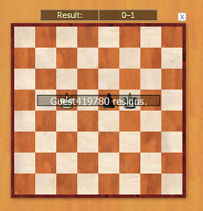

 | Guest629283 Eva Bartosova | 1–0 | Guest628728
5m + 0s1.e4 1.8 e5 1.7 2.Nf3 2.3 Nc6 1.4 3.Bb5 2.5Nf6 1.4 4.Bxc6 2.7 bxc6 3.3 5.Nxe5 2.1 Bd6 2.16.d4 11 0-0 2 7.Nc3 5.4 c5 7 8.Nf3 7 cxd4 2.19.Nxd4 3.2 Bb4 4.8 10.f3 6.6 Nxe4 7.2 11.fxe43.7 Qh4+ 1.9 12.Kd2 18 Bxc3+ 3.6 13.bxc3 7.9Qxe4 6.7 14.Qf3 4.4 Qxf3 37 15.Nxf3 2.7 Bb71.9 16.Rf1 4.6 f6 12 17.Ba3 2.8 Rfe8 2.318.Rae1 3 Kf7 2.2 19.Rxe8 6.1 Rxe8 1.920.Re1 3.2 Bxf3 5 21.gxf3 2.9 Rxe1 4.522.Kxe1 2 Ke6 8 23.Bf8 2.5 g6 6.8 24.Bc5 4.4a6 4.1 25.Ba7 4.6 Kd5 36 26.Bb8 2.6 c5 5.427.Bg3 6.1 g5 9.7 28.Ke2 2.5 f5 2 29.Ke3 6.7Kc4 33 30.Bd6 8.6 Kd5 18 31.Be7 3.8 Kc4 2032.Bf6 7.2 d5 14 33.Kd2 6.7 g4 7.9 34.fxg4 5.8fxg4 1.5 35.Be5 19 h5 30 36.Bg3 20 . d4 3.137.cxd4 4.6 cxd4 2.4 38.Bf2 5.2 a5 2.7 39.Bg32.8 Temps1–0

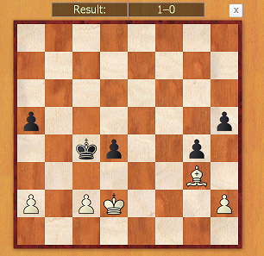

 | Guest689090 Eva Bartosova | ½–½ | Guest684870
5m + 0s1.e4 3.1 c5 1.9 2.Nf3 2 e6 2.2 3.d4 2.1cxd4 1.9 4.Nxd4 1.5 Nf6 1.1 5.Nc3 2 Nc61.3 6.Nxc6 2.4 bxc6 2.5 7.Bg5 2.3 Bb4 3.18.Bd3 2.5 h6 26 9.Bxf6 2.1 Qxf6 2.5 10.Qf32.9 Qxf3 5.5 11.gxf3 3 d5 1.8 12.0-0-0 3.1Bxc3 2.4 13.bxc3 2.3 Ke7 2.6 14.c4 3.4dxc4 19 15.Bxc4 2.3 Rd8 15 16.Rd2 2.8Rxd2 2.6 17.Kxd2 2 Rb8 1.9 18.Rg1 4.5 g61.8 19.Bb3 12 e5 9.4 20.Re1 14 Be6 2.921.Re3 2.7 Rd8+ 12 22.Ke2 5 c5 1723.Bxe6 6.6 Kxe6 2.3 24.Rc3 5.8 Rc8 4.525.Ra3 2.5 Rc7 2.1 26.Ra6+ 3.7 Ke7 2.827.c4 8.8½–½

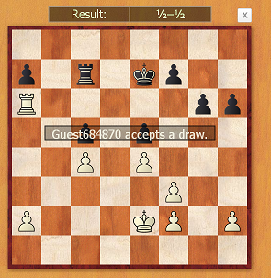

Guest841954 Eva Bartosova | 0–1 | Guest845113
5m + 0s1.e4 2.8 e5 1.6 2.Nf3 1.8 Nf6 2.4 3.Nxe52.4 Qe7 5.6 4.f4 17 Nxe4 2.3 5.Bd3 7.7 d63.8 6.Bxe4 10 dxe5 2.6 7.fxe5 2.4 Qxe5 2.88.d3 9 Nd7 4 9.0-0 8.4 Nf6 3 10.Bf4 3.3Qxb2 3.6 11.Nd2 3.5 Bb4 8.2 12.Nc4 5.9Qd4+ 12 13.Kh1 12 Bc5 7.8 14.Bxc7 6.30-0 10 15.Qg4 22 Nxe4 9.7 16.dxe4 7Bxg4 17 17.h3 20 Be2 3.1 18.Rfe1 6.2Bxc4 3.40–1

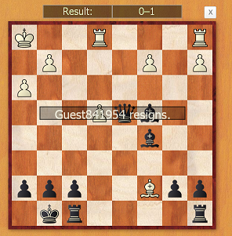

Guest1305427 Eva Bartosova | 1–0 | Guest1272596
5m + 0s1.e4 2.5 e5 0.3 2.Nf3 1.8 Bc5 0.6 3.d31.7 d6 2.8 4.Be3 2.2 Bxe3 3.9 5.fxe3 8.6Nc6 1.9 6.Nc3 2.1 Be6 2.7 7.Be2 5.8Nge7 2.5 8.0-0 1.7 0-0 3.7 9.Ng5 1.7 Bd74.1 10.Bg4 4.9 Ng6 4.3 11.Bxd7 3.5 Qxg54 12.Bxc6 3.8 Qxe3+ 3.1 13.Kh1 5.8bxc6 1.5 14.Rf3 5.4 Qg5 44 15.Qe2 5.2Nf4 2.3 16.Qf2 7.5 Rab8 1.5 17.Ne2 34 '1–0

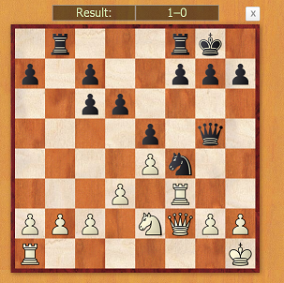

Guest1305427 Eva Bartosova | 1–0 | Guest1223981
5m + 0s1.e4 3.4 b5 2.9 2.Nf3 2.1 Bb7 1.7 3.Nc33.1 b4 4.4 4.Nd5 3.1 a5 6.9 5.d3 4.2 e68.5 6.Nf4 2.4 e5 2.3 7.Nxe5 5.3 Bd6 7.38.d4 3.1 Bxe5 5.8 9.dxe5 2 Bxe4 110.Bd3 3.5 Bxd3 2 11.Qxd3 2.6 Ra6 2.212.0-0 4.5 Nh6 8 13.Nd5 4 Qc8 2514.Bxh6 1 gxh6 6.2 15.Qg3 16 c6 1:4916.Nf6+ 6.5 Guest1223981 resigns1–0

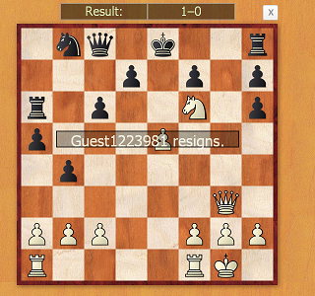

Guest1504572 Eva Bartosova | ½–½ | Guest1503448
5m + 0s1.e4 2.1 c5 1.9 2.Nf3 2.1 Nc6 1.4 3.d3 1.9d6 2.3 4.Be2 2.7 g6 2 5.0-0 2.7 Bg7 2.16.Nc3 3 Nf6 2.1 7.Nd5 3 Nxd5 3.2 8.exd51.8 Ne5 2 9.Nxe5 2 Bxe5 2.3 10.c4 2.2 0-03.7 11.Be3 4.9 e6 12 12.Qd2 2.8 exd5 2.513.cxd5 2.2 Qf6 2.7 14.Rab1 3.4 Bd7 2715.b3 9 Bc3 6.4 16.Qc2 5.3 Bd4 4.817.Bxd4 2.3 Qxd4 2.7 18.Qc4 4.7 Qxc4 1619.dxc4 1.7 Rfe8 1.7 20.Bf3 5.2 a5 4.621.h3 2.1 b5 4.9 22.Rfe1 5.9 b4 2.623.Rxe8+ 3.3 Bxe8 2.3 24.Re1 4.1 Kf8 325.Ra1 13 a4 2.5 26.Rb1 9.8 axb3 3.827.axb3 2.3 Ra2 2.2 28.Bd1 5.3 Bd7 7.229.Bg4 4.7 Bxg4 4 30.hxg4 1.8 Ke7 9.431.f3 4.6 Kd7 5.5 32.Kh2 2.1 h6 5.1 33.Kh32.4 Rd2 17 34.g3 0.1 Rd3 4.3 35.f4 0.2 Ke74.9 36.g5 8.4 hxg5 3.7 37.fxg5 2.1 Kd7 3.338.Kg4 9.6 Ke7 4.4 39.Kf4 3 Kf8 3.5 40.g44.5 Kg7 2.1 41.Rb2 7.8½–½

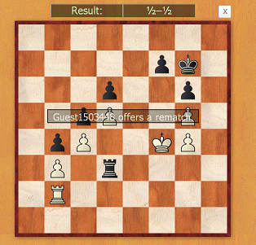

 | Guest2117348 Eva Bartosova | 1–0 | Guest2059473
5m + 0s1.e4 3.1 h6 1.6 2.d4 2.3 e6 1.2 3.Nf3 3.2d5 1.1 4.e5 1.6 c5 1.5 5.c3 1.8 Qb6 1.76.Nbd2 13 Nc6 2 7.Be2 2.4 cxd4 2.18.cxd4 3.3 Bd7 4.4 9.Nb3 2 Bb4+ 3.210.Bd2 4.4 Bxd2+ 1.7 11.Qxd2 2 Rc8 4.612.0-0 2.1 Nge7 3.5 13.Rac1 5.2 0-0 1.914.Rc3 4.7 Na5 20 15.Nxa5 3.6 Qxa5 8.616.Rfc1 5.3 Rxc3 7.4 17.Rxc3 5.7 Qxa26.5 18.Rc7 2.5 Qa1+ 14 19.Bf1 5.3 Rd819 20.Rxb7 2.9 Bc6 12 21.Rxe7 4.4 Bb54.2 22.Ne1 5.3 Bxf1 1.8 Guest2059473 gibt auf1–0

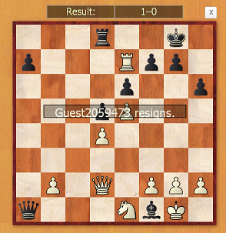

 | Guest2380242 Eva Bartosova | 1–0 | Guest2380229
 | Interesting
5m + 0s1.e4 2.5 c6 1.4 2.d3 1.8 d5 1.5 3.exd53.4 cxd5 1.7 4.Nf3 2 Nc6 1.4 5.Be2 2.4Bg4 1.3 6.Nc3 3 e6 1.7 7.0-0 2.8 Nf6 1.38.Bg5 4.4 Be7 1.5 9.Bxf6 2.1 Bxf6 2.210.Qd2 3.2 0-0 9 11.Rfe1 6.4 Rc8 3.112.h3 1.5 Bh5 3.1 13.g4 13 Bg6 4.614.h4 4.2 h5 3.6 15.gxh5 7.8 Bxh5 3.316.Nh2 7.4 Bxe2 6 17.Rxe2 2.7 Bxh4 4.418.Re3 3.1 Bg5 2.3 19.f4 3.5 Bxf4 8.520.Qe2 5.8 Qg5+ 12 21.Kf1 28 Bxe3 6.622.Ke1 11 Nd4 6.1 23.Qg4 9.1 Nxc2+ 2024.Ke2 3.4 Nxa1 15 25.Qxg5 4.5 Bxg52.2 26.Nf3 4.5 Bf6 9 27.Kd1 3.4 Bxc3 3.528.bxc3 3.2 Rxc3 1.4 29.Ne1 4.4 Rc1+4.3 30.Kxc1 3.9 Rc8+ 1.4 31.Kd1 2.3Rc1+ 2 32.Kxc1 2.2 Nb3+ 1.8 33.axb32.7 Kf8 1.2 34.Nf3 3.1 Ke7 3.6 35.Ne5 2.3f6 3.5 36.Nf3 3.4 Kd6 3.2 37.d4 3.2 e51.7 38.dxe5+ 3.3 fxe5 1.1 39.Kd2 3.8 a51.4 40.Ng5 3.3 b5 6.1 41.Kc3 2.8 a4 842.bxa4 2.6 b4+ 1.7 43.Kxb4 1.6 Kc7 4.844.Nf3 3.8 e4 4 45.Nd4 2.6 g5 2.6 46.a52 g4 4.9 47.Ne2 1.8 Kc6 11 48.a6 6 Kb65.8 49.a7 3.2 Guest2380229 resigns1–0



